**Activity 5 & 6**

**FIFO:**

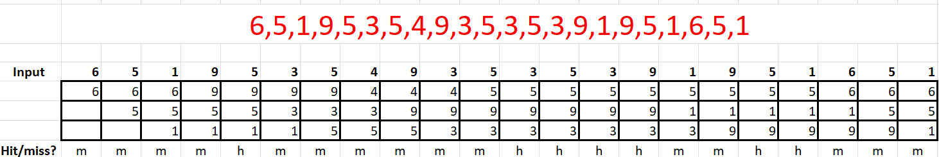

Total hits = 7

Total misses = 15

**LRU:**

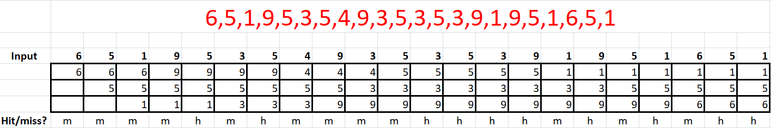

Total hits = 10

Total misses = 12

LRU has lesser number of page faults (misses) than FIFO, hence LRU is a better performing page replacement algorithm.